HW#1 p510 #1-6, 11-19 odd, 20,21
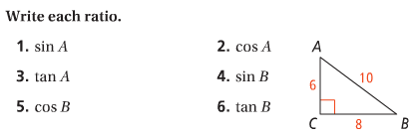
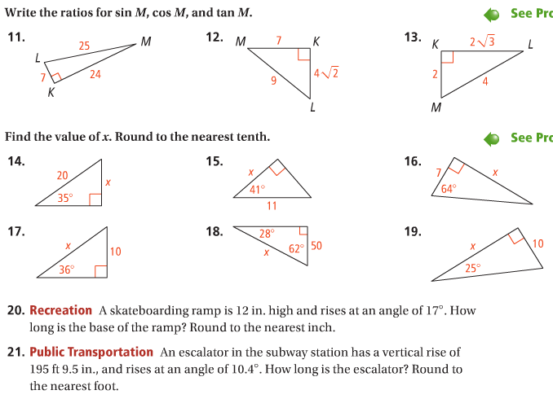

HW#2 p511 #23-27 odd, 33, 35, 37a
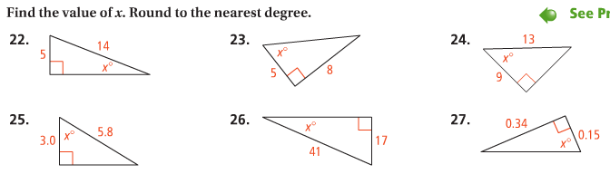
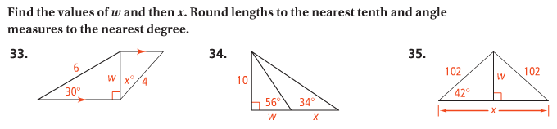
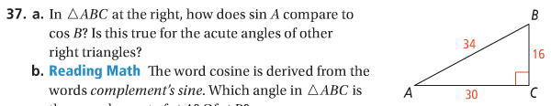

HW#3 p519 #17-24, 34
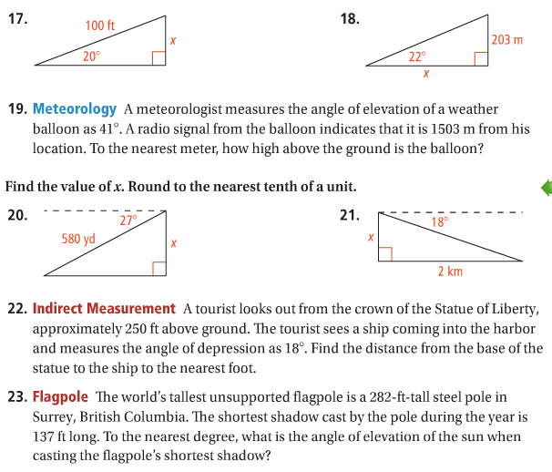
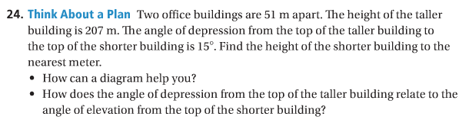
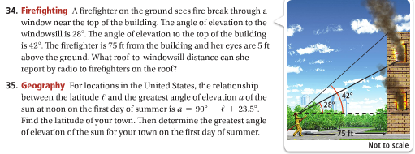
HW#5 p503 #7-19 odd, 25, 27
